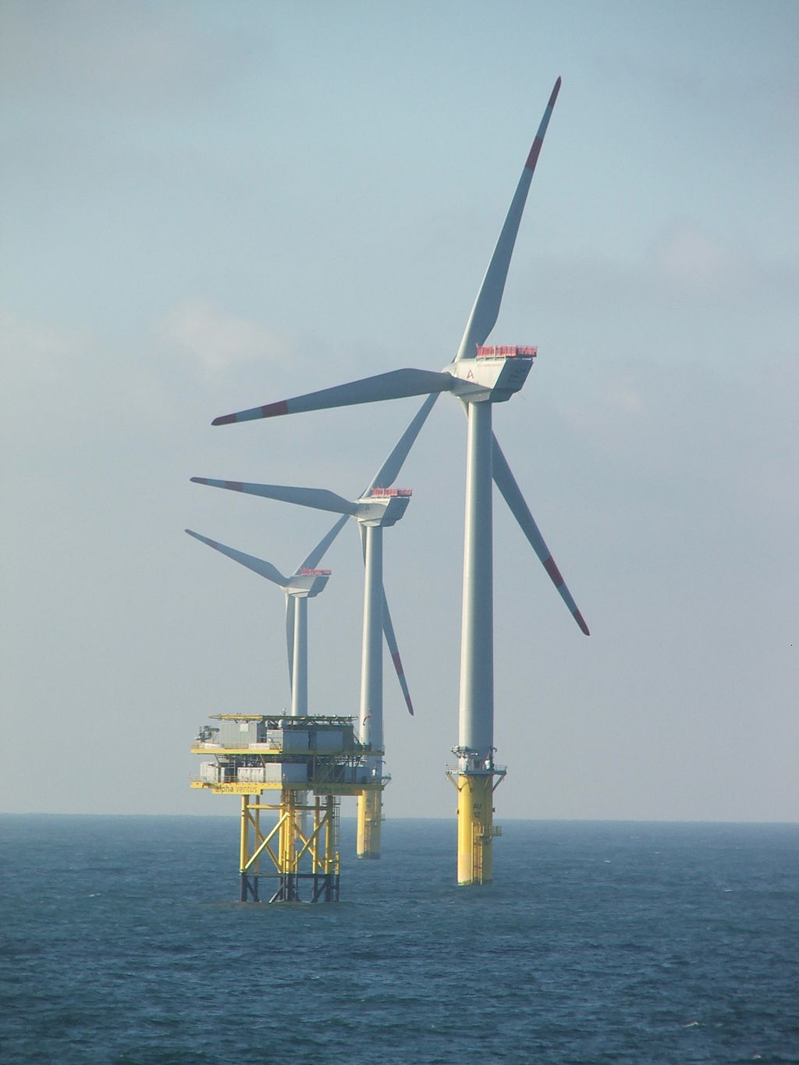

**CONSIDERING FISHERIES IMPACTS DURING ALLOCATION OF   
OFFSHORE WIND FARMS (OWF) LEASES**

Steve Swartz

SwartzSt@oregonstate.edu

Duc Le

[lephuo@oregonstate.edu](mailto:lephuo@oregonstate.edu)

## Summary

The global pursuit of clean energy necessitates the expansion of renewable sources, with offshore wind energy offering substantial potential due to its high generation capacity and minimal land footprint. However, the development of offshore wind farms (OWFs) introduces complex spatial considerations, particularly concerning their interaction with existing marine activities such as commercial fisheries, wildlife, and tourism. Traditional OWF siting models often prioritize energy output, overlooking the crucial need for a comprehensive approach that integrates social, economic, and environmental factors.

This paper delves into the strategic siting of floating offshore wind farms along the Oregon coastline. It presents a novel spatial optimization framework developed to assess the economic advantages of power generation in contrast with the potential financial detriments to crucial fishing sectors. The framework utilizes a grid-based approach, integrating comprehensive wind data from the National Renewable Energy Laboratory (NREL) with representative fisheries activity information. By computing a net economic value—derived from projected electricity revenue minus estimated fishery losses—for each potential location, the system identifies and ranks the most favorable development sites. This flexible design allows for subsequent integration of broader environmental and socio-economic factors, fostering a genuinely holistic marine spatial planning process. The analysis underscores how judicious OWF placement can both maximize clean energy output and mitigate negative consequences for Oregon's significant coastal assets.

## 1. Background

The global imperative to transition towards sustainable energy sources has accelerated the development of offshore wind energy. As a high-capacity, low-carbon alternative to traditional fossil fuels, offshore wind offers significant potential for large-scale electricity generation, particularly in regions with strong, consistent wind resources like the U.S. West Coast. However, the expansion of offshore wind farms (OWFs) into marine environments introduces a range of complex interactions with existing ocean uses and ecosystems. These interactions necessitate careful planning and robust assessment to ensure equitable and sustainable development.

### 1.1. State of the Science

The scientific understanding of offshore wind energy development and its multifaceted impacts is rapidly evolving. Research has focused on various aspects, including technological advancements in floating wind turbines, environmental effects on marine life, and socio-economic consequences for coastal communities. A key area of concern is the potential conflict with commercial fisheries, a vital economic sector in many coastal regions.

Studies have highlighted the need for comprehensive marine spatial planning (MSP) to mediate these conflicts. For instance, Chaji and Werner (2023) provide an overview of industry perceptions, methods, and knowledge gaps concerning the economic impacts of OWFs on fishing industries, emphasizing the uncertainties in assessing these impacts. Prince et al. (2023) explore co-location strategies for fisheries and OWFs in the North Sea, identifying current practices and enabling conditions for co-existence. These papers underscore the importance of understanding the spatial and temporal dynamics of fishing activities and their potential overlap with proposed wind energy development areas.

The concept of evaluating ecosystem services through tradeoff analysis is vital in this context. White et al. (2024) illustrate the utility of marine spatial planning for managing multiple ocean uses by examining the compromises between renewable energy development, fisheries, seabirds, and cetaceans in California, offering a pertinent framework for application in Oregon. Similarly, Wang et al. (2022) provide foundational data by detailing the spatial and temporal characteristics of California's commercial fisheries and their potential overlap with offshore wind energy development. The economic consequences for fisheries, including potential displacement and shifts in fishing behaviors, represent a significant consideration (Feist et al. 2025). Furthermore, Perry & Heyman (2020) and Stelzenmüller et al. (2021) have explored the complexities of co-locating fisheries and wind farms, recognizing the potential for both beneficial and detrimental outcomes. These collective insights emphasize that effective spatial planning must balance the value of emerging ocean industries with their impacts on existing sectors and the broader marine environment.

### 1.2. Relevant Policies

In the United States, the advancement of offshore wind energy is guided by a combination of federal and state policies. These frameworks are designed to promote renewable energy objectives while simultaneously ensuring responsible management of marine environments. The Bureau of Ocean Energy Management (BOEM) plays a central role at the federal level, overseeing offshore energy initiatives, including the process of leasing areas for OWF construction. Concurrently, individual states, such as Oregon, are developing their own specific policy structures and targets for offshore wind. These state-level efforts frequently align with broader climate and energy goals. A common thread across these policies is a strong emphasis on engaging stakeholders, conducting thorough environmental impact assessments, and striving to minimize any adverse effects on existing marine activities, which encompass commercial fishing, wildlife conservation, and tourism.

### 1.3. Audience Consideration

This white paper is intended for a diverse audience, including policymakers, energy developers, fishing industry representatives, environmental organizations, and researchers engaged in marine spatial planning. The objective is to offer a clear, data-driven understanding of the complexities involved in siting offshore wind farms and to present a methodological approach that can foster more informed and equitable decision-making. Recognizing the distinct values and concerns of each stakeholder group—from the economic viability of fishing fleets to the ecological protection of marine ecosystems and the sustainability of coastal tourism—is paramount for achieving successful and sustainable offshore wind development.

## 2. Problem Description

Oregon, with its abundant offshore wind resources, is poised to play a significant role in the nation's clean energy transition. However, the strategic placement of floating offshore wind turbine farms off its coast presents a multifaceted challenge. While the benefits of clean electricity are clear, the deployment of these large-scale infrastructure projects carries potential costs that can offset these advantages.

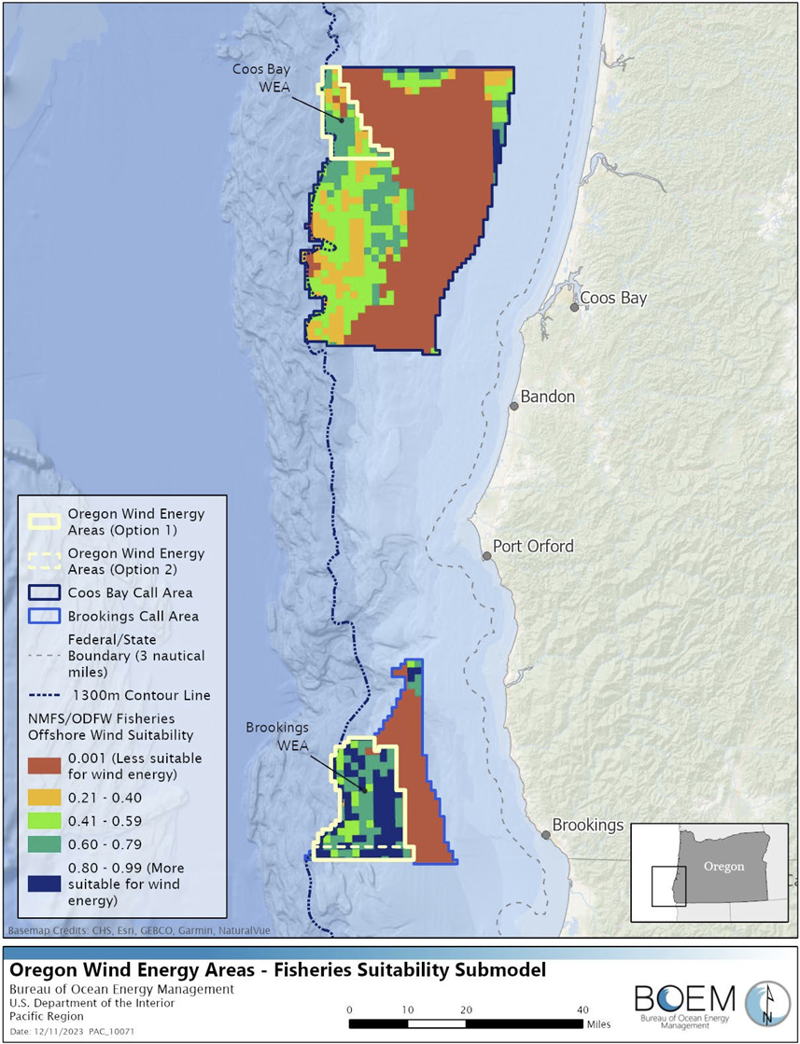

Figure 1: Map of suitability of fisheries activity ranked to the Coos Bay WEA and Brookings WEA.

Source: BOEM, NCCOS

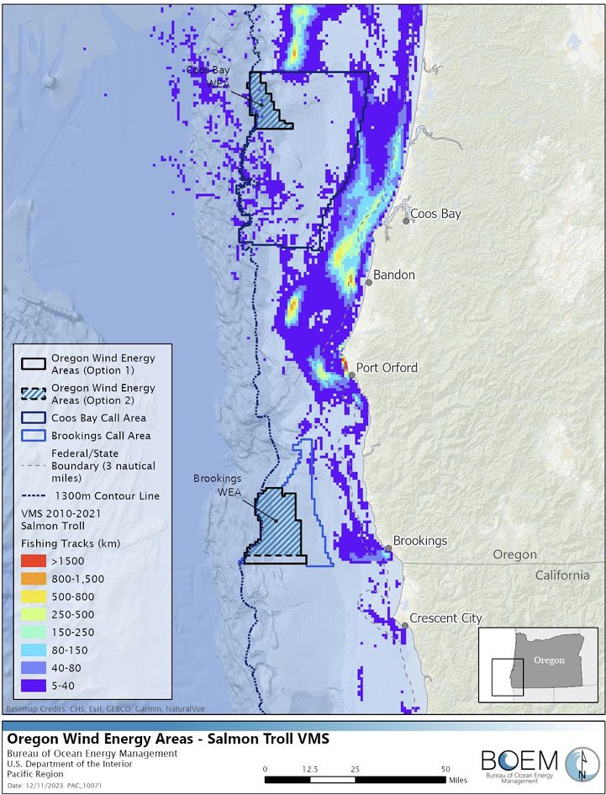

Figure 2: Map of Coos Bay and Brookings WEA Options overlayed with Pacific salmon troll data

Source: NOAA Office of Law Enforcement, California State Polytechnic University, BOEM

### 2.1. Overview of the Problem

The core problem lies in the inherent spatial conflict between new offshore wind energy development and established marine industries, encompassing not only commercial fisheries but also vital coastal resources such as wildlife and tourism. Oregon's coastal waters are home to a vibrant and economically significant fishing industry, supporting numerous livelihoods and contributing substantially to the state's economy. The proposed offshore wind development areas often overlap with traditional fishing grounds, leading to concerns about:

* **Displacement of Fishing Effort:** The physical presence of wind turbines, associated infrastructure (e.g., cables, substations), and exclusion zones can directly displace fishing vessels from historically productive areas. This can force fishers to travel further, incur higher fuel costs, and potentially access less productive grounds, leading to reduced catches and revenue.
* **Impacts on Fish Stocks and Ecosystems:** The construction and operation of OWFs can alter marine habitats, create underwater noise, and potentially affect fish migration patterns and spawning grounds. While some studies suggest potential benefits (e.g., artificial reef effects), the overall impact on commercially important species and the broader ecosystem is a subject of ongoing research and concern (Perry & Heyman 2020, Stelzenmüller et al. 2021).
* **Impacts on Wildlife:** OWFs can affect marine wildlife, including seabirds (e.g., collision risk, habitat displacement) and cetaceans (e.g., noise disturbance during construction and operation, potential alteration of migration routes).
* **Impacts on Tourism and Views:** The visual presence of wind turbines from the shore can impact coastal tourism, which is a significant economic driver for many Oregon communities.
* **Economic Valuation Challenges:** Quantifying the economic impacts on fisheries, tourism, and the ecological value of biodiversity is complex. It involves not only direct revenue loss but also indirect effects on supply chains, processing, and coastal communities. Comparing these nuanced economic costs with the direct economic benefits of electricity generation requires a robust and transparent framework.
* **Lack of Integrated Spatial Planning:** Most existing models for offshore wind farm siting focus mainly on energy generation (power output), overlooking the critical need for a holistic approach that accounts for social, economic, and environmental factors. Without a comprehensive, spatially explicit framework that can quantitatively assess and compare these diverse impacts, decision-making regarding OWF siting can be ad-hoc, leading to suboptimal outcomes, increased stakeholder conflict, and potential delays in project development.

The current status quo, characterized by a lack of an integrated spatial optimization tool, risks sub-optimal siting decisions that could either underutilize valuable wind resources or impose disproportionate burdens on the fishing industry, wildlife, and tourism sectors. This highlights the urgent need for a systematic approach to balance these competing interests.

### 2.2. Stakeholder Values

Various stakeholder groups hold distinct values concerning offshore wind development:

* **Energy Developers:** Value high wind resources, proximity to grid connections, cost-effectiveness, and regulatory certainty to maximize energy production and financial returns.
* **Commercial Fishers:** Value access to traditional fishing grounds, healthy fish stocks, continuity of their livelihoods, and fair compensation for any unavoidable impacts. Their primary concern is the potential loss of fishing revenue and disruption to established practices, which are vital for coastal communities.
* **Environmental Organizations:** Value the reduction of carbon emissions through renewable energy, but also prioritize the protection of marine ecosystems, biodiversity (which is essential for long-term ecosystem services), and sensitive species (e.g., whales, seabirds) from potential negative impacts of OWF construction and operation.
* **Coastal Communities:** Value economic development, job creation, and reliable energy supply, but also express concerns about visual impacts, potential changes to coastal tourism (which coastal communities depend on), and the preservation of local character and industries.
* **State and Federal Regulators:** Value balancing economic development with environmental protection, ensuring public safety, and facilitating orderly and transparent marine spatial planning processes.

The impacts of offshore wind development must be related to these values. For instance, reduced fishing access directly impacts the economic value for commercial fishers, while increased electricity generation contributes to the energy security and climate goals valued by regulators and environmental groups.

### 2.3. Status Quo Consequences

Maintaining the status quo—where siting decisions are made without a robust, quantitative spatial optimization framework that explicitly balances energy and other vital coastal resources—carries significant consequences for all stakeholder groups:

* **For Energy Developers:** Increased risk of project delays due to prolonged permitting processes, legal challenges from opposition groups, and potential for siting in areas with lower net economic benefit due to unforeseen conflicts.
* **For Commercial Fishers:** Continued uncertainty regarding future access to fishing grounds, potential for significant unmitigated economic losses, and erosion of trust in the planning process.
* **For Environmental Organizations:** Risk of OWF placement in ecologically sensitive areas if environmental impacts are not adequately quantified and factored into spatial decisions.
* **For Coastal Communities:** Potential for social and economic disruption if local industries (like fishing or tourism) are severely impacted, or if the perceived benefits of OWFs do not materialize locally.
* **For Regulators:** Challenges in achieving state and federal energy goals efficiently, increased administrative burden from mediating conflicts, and difficulty in demonstrating transparent and equitable decision-making.

Ultimately, the status quo risks sub-optimal development that fails to maximize the overall societal benefit from offshore wind, leading to protracted conflicts and hindering Oregon's progress towards a sustainable blue economy.

## 3. Proposed Solution: A Spatial Optimization System for Offshore Wind Siting

To address the complex spatial conflicts arising from offshore wind farm development, we propose and implement a spatial optimization system. This system is designed to provide a quantitative framework for evaluating potential offshore wind sites by explicitly balancing the economic benefits of electricity generation against the economic costs to commercial fisheries. The primary objective is to maximize thez "profit," defined as the net economic value derived from a given site (electricity revenue minus fishery loss).

### 3.1. Acceptable Solution Criteria

For any proposed solution to be effective in mediating the conflicts between offshore wind development and fisheries, it must fulfill several critical criteria:

* **Quantitative Assessment:** The solution must provide a quantifiable measure of both benefits (electricity generation) and costs (fishery impacts) in a common economic unit (e.g., dollar values) to allow for direct comparison and optimization.
* **Spatially Explicit:** The analysis must account for the geographical variation in wind resources, fishing activity, and potential impacts across the study area. This requires a grid-based or similar spatial framework.
* **Data-Driven:** The system should leverage available scientific data and robust methodologies for assessing wind potential and characterizing fisheries.
* **Transparent and Reproducible:** The methodology should be clear, well-documented, and capable of being replicated by others, fostering trust among stakeholders.
* **Modular and Adaptable:** The framework should be designed to easily incorporate additional impact categories (e.g., tourism, wildlife, shipping) in future iterations without requiring a complete overhaul.
* **Actionable Insights:** The output must provide clear, ranked recommendations for optimal siting that can directly inform marine spatial planning and policy decisions.

### 3.2. Proposed Spatial Optimization System

Our implemented system, developed in R, integrates various spatial and economic datasets to perform a comprehensive tradeoff analysis. The core steps are outlined below, reflecting the structure and functions within the provided R code.

#### 3.2.1. Lease Area and Grid Creation

The initial phase involves defining the geographical scope of the analysis and establishing a high-resolution grid for subsequent assessments.

**Lease Areas:** Specific conceptual offshore wind development zones are delineated for Oregon, identified as "Coos Bay" and "Brookings." These areas are defined by their respective longitudinal and latitudinal boundaries (e.g., Brooking: −124.8° to −124.3° longitude, 42° to 42.8° latitude).

**Analysis Grid:** Within these designated lease areas, a uniform grid composed of 2x2 km cells is generated. Each cell represents a discrete potential site for offshore wind development and is assigned a unique *site_id*. The geographic centroids of these cells serve as reference points for data retrieval and spatial computations. This fine-grained resolution facilitates detailed spatial analysis of varying conditions across the study region.

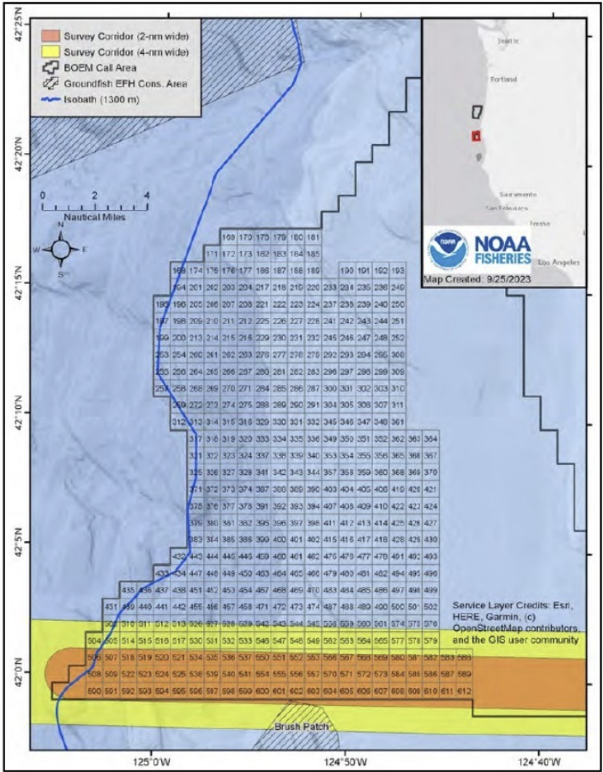

Figure 3: Areas requested by NOAA for removal from the Brooking Draft WEA due to scientific surveys.

Source: NOAA comment letter (BOEM-2023-0033-0508)

#### 3.2.2. Wind Resource Assessment and Electricity Generation

This component quantifies the energy generation potential and corresponding revenue for each individual grid cell.

* **Bulk Wind Data Download:** The system efficiently accesses comprehensive wind speed data from the National Renewable Energy Laboratory (NREL) Wind Toolkit API. A dedicated function *(download_oregon_wind_bulk*) constructs a Well-Known Text (WKT) polygon that encompasses the entire analysis grid. This polygon is then used to request hourly wind speed data (e.g., for the year 2019) at multiple heights (80m, 100m, 120m) for all NREL data points within the specified bounding box. This bulk download methodology significantly enhances efficiency compared to making individual API calls for each grid cell.
* **Data Processing and Capacity Factor Calculation:** The raw wind data obtained is processed to accurately associate the closest NREL wind data point with each 2 km grid cell. For every cell, the mean wind speed at the assumed turbine hub height (120m for modern large turbines) is calculated. Subsequently, the capacity factor is then determined using a simplified power curve model *(calculate_capacity_factor_from_hourly)*. This model estimates the proportion of time a turbine operates at its maximum rated power, taking into account critical wind speed thresholds: cut-in (3.0 m/s), rated (12.5 m/s), and cut-out (25.0 m/s).
* **Electricity Revenue Calculation:** Annual electricity generation and revenue per grid cell are estimated assuming a 12 MW turbine capacity and a wholesale price of $55/MWh.

Figure 4: Potential energy impact of the Oregon Offshore wind energy lease sale.

Source: BOEM, NCCOS

#### 3.2.3. Fisheries Data Simulation and Spatial Allocation

Due to limited publicly available spatial fisheries data for this demonstration, we simulate vessel activity including gear types (trawl, longline, crab pot, gillnet), trip dates, fishing locations, and catch revenues. In operational contexts, this would be replaced by Vessel Monitoring System (VMS) data and commercial landings records to ensure empirical accuracy.

Fishing effort and revenue are allocated to grid cells intersecting fishing locations, producing annual average metrics of fishing revenue, trip frequency, and fishing hours per cell.

#### 3.2.4 Fishery Impact Estimation

Potential fishery losses due to OWF development are modeled under three scenarios (30%, 50%, 70% operational impact). Critically, this base impact is then adjusted based on the dominant gear type present in that cell and its specific "operational impact" (e.g., trawl fisheries 0.6 might experience a higher operational impact due to spatial exclusion compared to crab pots 0.4). This approach yields annual fishery loss estimates in millions of dollars per grid cell.

#### 3.2.5. Tradeoff Analysis and Site Ranking

The final component integrates the calculated energy benefits and fishery costs to identify optimal sites. This assessment employs a simple choice model, where a combined score quantifies the net impact by comparing positive (energy benefits) and negative (fishery costs) economic values at each grid location.

Energy revenues and fishery losses are normalized into dimensionless scores. A weighted combined score (default 60% energy, 40% fisheries) is calculated, reflecting the relative importance assigned to each objective.

Finally, grid cells are ranked based on their calculated *combined score*, with higher scores indicating more optimal sites for OWF development. This ranking provides a clear prioritization of potential OWF locations that maximize the net economic benefit, considering both electricity generation and fishery impacts.

## 4. Recommendations

(still working on it)

## 5. Conclusions

(still working on it)

## References

Chaji, M., & Werner, S. (2023). Economic Impacts of Offshore Wind Farms on Fishing Industries: Perspectives, Methods, and Knowledge Gaps. Marine and Coastal Fisheries: Dynamics, Management, and Ecosystem Science, 0(e10237).

Feist, B. E., Griffin, R., Samhouri, J. F., Riekkola, L., Shelton, A. O., Chen, Y. A., et al. (2025). Mapping the value of commercial fishing and potential costs of offshore wind energy on the U.S. West Coast: Towards an assessment of resource use tradeoffs. PLoS ONE, 20(3), e0315319.

Perry, R. L., & Heyman, W. D. (2020). Considerations for offshore wind energy development effects on fish and fisheries in the United States: A review of existing studies, new efforts, and opportunities for innovation. Oceanography, 33(4), 28–37.

Prince Owusu Bonsu, J. L., Yates, K. L., Svendsen, J. C., Berkenhagen, J., Rozemeijer, M. J. C., Kerkhove, T. R. H., Rehren, J., & Stelzenmüller, V. (2023). Co-location of fisheries and offshore wind farms: Current practices and enabling conditions in the North Sea. Marine Policy, 159, 105941.

Stelzenmüller, V., Gimpel, A., Haslob, H., Letschert, J., Berkenhagen, J., & Brüning, S. (2021). Sustainable co-location solutions for offshore wind farms and fisheries need to account for socio-ecological trade-offs. Science of the Total Environment, 776, 145918.

Wang, Y.-H., Walter, R. K., White, C., & Ruttenberg, B. I. (2022). Spatial and Temporal Characteristics of California Commercial Fisheries from 2005 to 2019 and Potential Overlap with Offshore Wind Energy Development. Marine and Coastal Fisheries: Dynamics, Management, and Ecosystem Science, 0(e10215).

White, C., Wang, Y.-H., Walter, R. K., Ruttenberg, B. I., Hand, D., Newman, E., Deyle, E. R., Gopal, S., & Kaufman, L. (2024). Spatial planning offshore wind energy farms in California for mediating fisheries and wildlife conservation impacts. Environmental Development, 51, 101005.

(23 more ref)